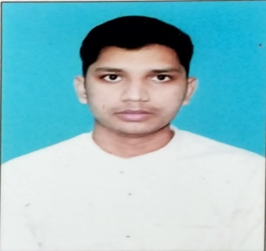**Praveen Kumar**

SDE Intern

Phone 7634916438

LinkedIn linkedin.com/in/praveen-pandey-744805248

E-mail [praveen1213qr@gmail.com](mailto:praveen1213qr@gmail.com)

**OBJECTIVE**

Seeking a learning position as a SDE Intern in an organization where I can utilize my skills in programming, problem-solving, and project management to develop innovative solutions that meet the needs of clients and users.

**EDUCATION**

CBSE (2018 – 2020)

Intermediate (12th Grade)

Amity University

BCA- Pursuing

2021-2024

**SKILLS**

C language

C++ Language

Communication Skill

Web development – Html, CSS, React, Bootstrap

Tools and Technologies- GitHub, Ms. Excel, PowerPoint, Ms. Word.

Problem-solving

**PROJECT**

Blood Bank Management System (2022) - Developed a web-based application using HTML, CSS, React, and JavaScript for managing blood bank activities and keeping track of donor and recipient details.

**CERTIFICATION**

Full-stack development: - The Complete Web Development Bootcamp (InternNexux)

Cyber Security: - International Webinar on “Understanding the Cyber Security Issues and Challenges due to Cyber Warfare”

Html training: - Spoken Tutorial Project at IIT Bombay

**LANGUAGE**

English

Hindi

French (a little bit)

**HOBBIES AND INTEREST**

Curiosity to learn new skills.

Watching Animes

Gaming

Attending Industry leaders talk shows.

**DECLARATION**

I look forward to the opportunity to contribute my skills and knowledge to the team at Trilogy Innovation as a SDE Intern.